Chapter 7, Problem 86.

Figure 7.146 shows a circuit for setting the length of time voltage is applied to the electrodes of a welding machine. The time is taken as how long it takes the capacitor to charge from 0 to 8 V. What is the time range covered by the variable resistor?

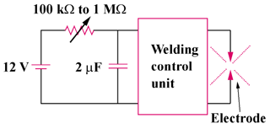

Figure 7.146
For Prob. 7.86.

